BPM Assignment

Pedro Henrique

1 Brainstorm a few options of how customers might be able to place order identify user persona based on this.

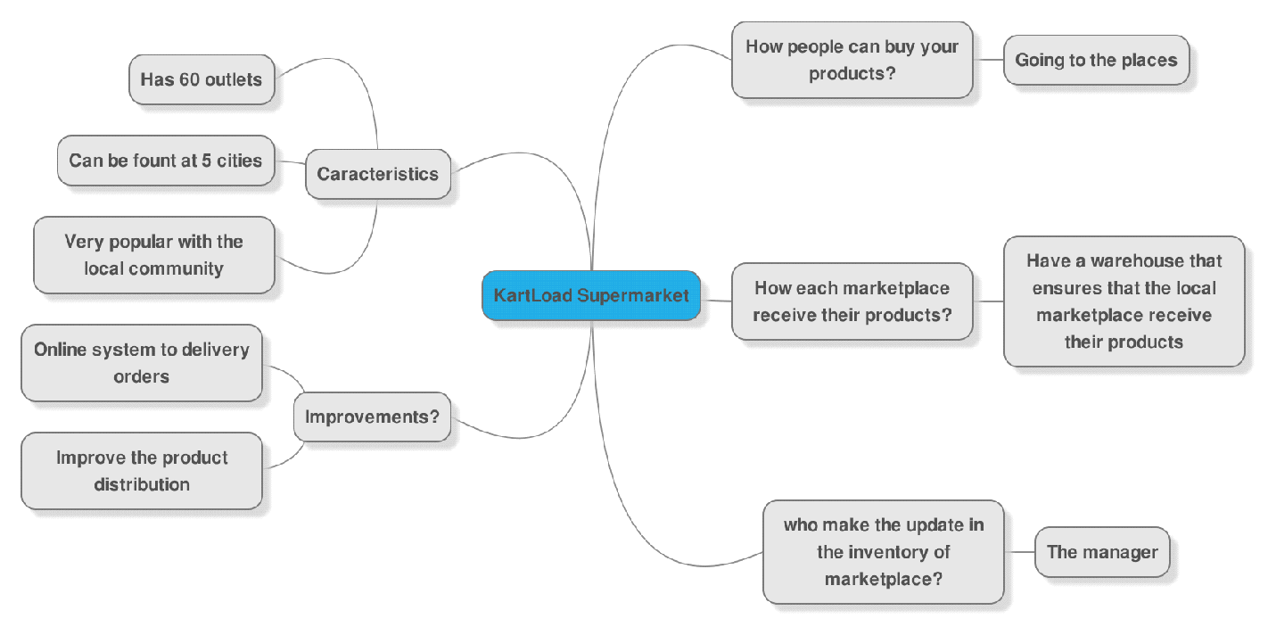
This Mind-Map describe some characteristics about the KartLoad Supermarket, show how people buy products on the store, how the market receives product to sell and some improvements. I could identify three types of personas: Customers, Supermarket Employees and Market Manager.

2 From the options you have brainstormed, illustrate one or more flows - of how users
can purchase an item from the supermarket (simple flow charts will suffice. Clearly state any assumptions you have made.)

First, I made the basic flow to a customer buy a product at the supermarket.
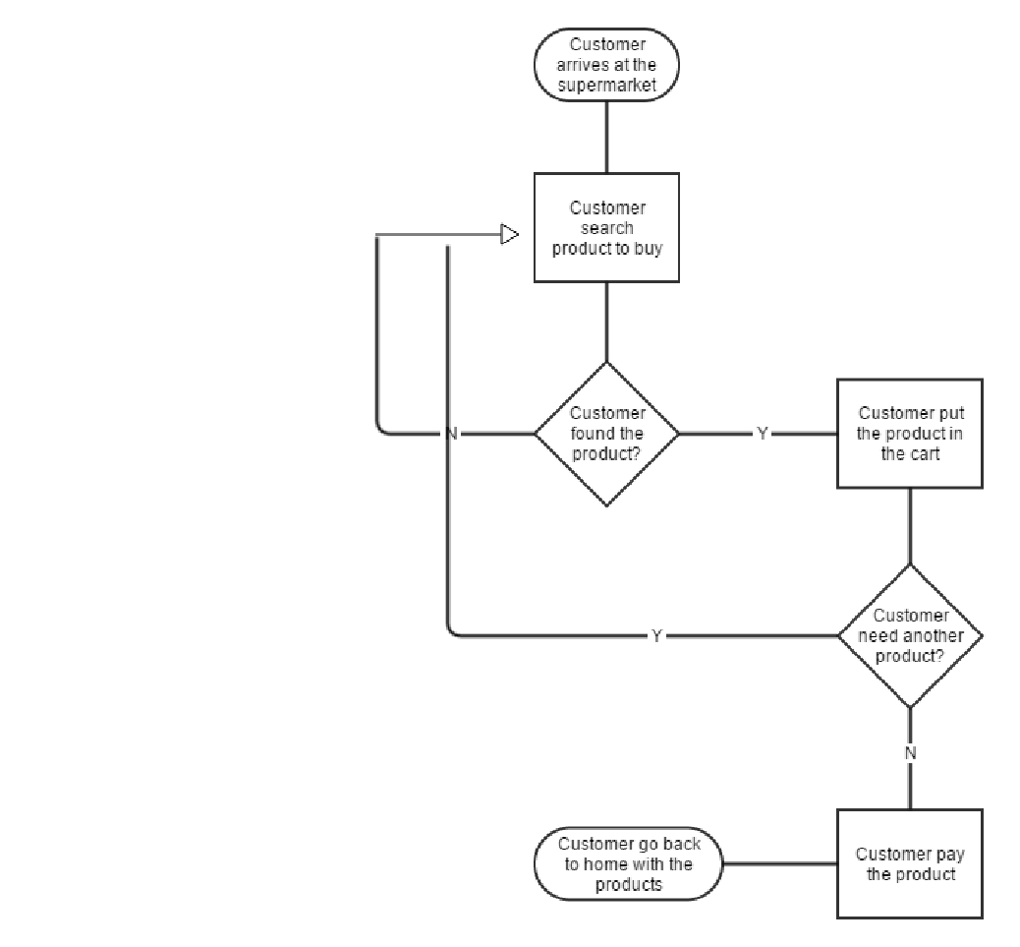

After that, I made other flow, to show how an Employee request new products from warehouse to supermarket. In this flow, I used 2 personas, the supermarket employee and store manager.
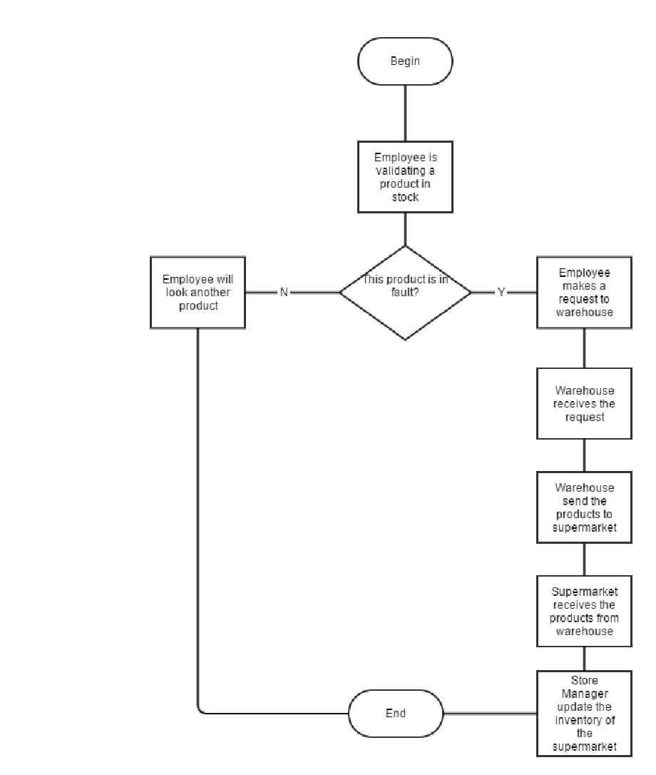

3 Identify and submit key user personas (in the format Introduced the part of the
reading content). Explain how / why you chose these personas.

Persona 1
Name: Diana
Age: 25 years old
Type of persona: Customer
What is she want? She wants some fruits
What she has? She has $10
What is your occupation? She’s student

Persona 2
Name: Tiago
Age: 15 years old
Type of persona: Supermarket Employee
What is your occupation? Supermarket Intern, He makes the catalog of stock.

Persona 3
Name: Pedro
Age: 30 years old
Type of persona: Manager
What is your occupation? Supermarket Manager, He makes the update in store inventory, staff and trains new workers

